DK-Audio
Marielundvej 37D
DK-2730 Herlev
Denmark

PT 5201

Compact VariTimeTM Sync Generator

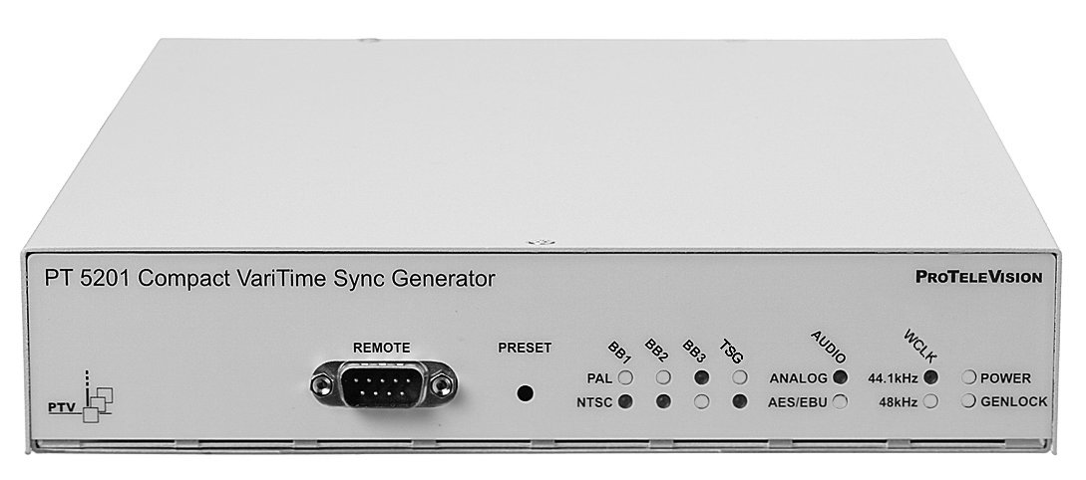

Operating Manual

PT 5201 Compact VariTimeTM Digital Sync Generator | Total number of pages: 69

Copyright © 2001 | PTV/DK-AUDIO, Denmark  All Rights Reserved
Printed in Denmark: April 25. 2000
Revision: 1
Publication number: 9499 491 02211

Contents

1 Safety 1-1
1.1 Introduction 1-1
1.2 Safety Precautions 1-1
1.3 Use of Caution and Warning Statements 1-1
1.4 Impaired Safety Protection 1-2
1.5 Technical specification 1-2
1.5.1 Equipment ratings 1-2
1.6 Electrostatic Sensitive Devices 1-3
1.7 Symbols 1-4
2 Introduction and Applications 2-1
2.1 Introduction 2-1
2.2 Configuration 2-1
2.3 Applications 2-2
3 Product Data 3-1
3.1 Safety Characteristics 3-1
3.2 Performance Characteristics 3-1
3.3 Summarized Data 3-1
3.3.1 Master Frequency Reference TCXO 3-1
3.3.2 Remote Control 3-1
3.3.3 Analog Genlock 3-1
3.3.4 Analog Black Burst Outputs 3-2
3.3.5 Test Signal Generator 3-2
3.3.6 AES/EBU Audio Generator 3-3
3.3.7 Wordclock (WCLK) Generator 3-4
3.3.8 Analog Audio Generator 3-4
3.3.9 Presets 3-5
3.4 Environmental Conditions 3-6
3.4.1 Regulations and Standards 3-6
3.4.2 Climatic Conditions 3-6
3.4.3 Mechanical Requirements 3-6
3.4.4 Safety: 3-6
3.5 Power Supply 3-6
3.6 Mechanical Data 3-6
4 Installation 4-1
4.1 Accessories 4-1
4.2 Initial Inspection 4-1
4.3 Safety Instruction 4-1
4.3.1 Grounding 4-1
4.4 Mains Voltage Cord and Fuses 4-1
4.5 Rack Mounting 4-2
4.6 Access to and Replacement of Parts 4-4
5 Operating Instructions 5-1
5.1 Instrument description 5-1
5.2 Front panel 5-1
5.3 How to get started 5-2
5.4 Rear panel 5-3
5.5 Windows interface 5-3
5.5.1 Application description 5-3
5.5.2 Menu description 5-4
6 Remote Interface 6-1
6.1 General Description of the Interface Syntax 6-1
6.1.1 Connector Description 6-1
6.1.2 Protocol 6-1
6.1.3 CONFIGURATION AND SYNTAX 6-2
6.1.4 General Information 6-3
6.1.5 Syntax Elements 6-3
6.1.6 Command Syntax 6-4
6.1.7 Syntax of Program Messages 6-4
6.1.8 Long and Short Form 6-5
6.1.9 Syntax of Response Messages 6-5
7 Commands summary 7-1
7.1 Mandated Commands 7-1
7.2 Required commands 7-1
7.2.1 SYSTem subsystem 7-1
7.2.2 STATus subsystem 7-2
7.3 Instrument commands 7-2
7.3.1 INPut subsystem 7-2
7.3.2 OUTPut subsystem 7-2
8 Commands Explanation. 8-1
8.1 Mandated Commands 8-1
8.2 Required Commands 8-2
8.2.1 SYSTem commands 8-2
8.2.2 STATus commands 8-3
8.3 Instrument Commands 8-3
8.3.1 INPut commands 8-4
8.3.2 OUTPut commands 8-5
9 Error Codes 9-1
9.1 Command errors [-199, -100] 9-1
9.2 Execution errors [-299, -200] 9-2
9.3 Device specific errors [-399, -300] 9-3
9.4 Query errors [-499, -400] 9-3
10 PT 5201 Signals 10-1
10.1 Video patterns. 10-1
10.2 Pattern selections after system change 10-2
10.3 Audio signals 10-2
10.4 Reset configuration 10-4

Page left intentionally blank

Safety

Read this chapter carefully before installation and use of the instrument.

Introduction
The instrument described in this manual is designed to be used by properly trained personal only.

Only qualified personnel who are aware of hazards involved shall carry out adjustment, maintenance and repair of the exposed equipment.

Safety Precautions
For the correct and safe use of the instrument, it is essential that both operating and servicing personnel follow generally accepted safety procedures in addition to the safety precautions specified in this manual. Specific warning and caution statements, where applicable, are found throughout this manual.
Warning and caution statements and/or symbols are marked on the instrument as well.

Special attention must be paid to the following issues:
- Protective grounding of the instrument is required for the accessible terminals to be safe.
(IEC 1010-1 Safety class I instrument)
- The actual environmental conditions must be checked against the specification.
- Mains voltage must be inside the specified range.

The opening of covers or removal of parts, except those to which access can be gained by hand, is liable to expose live parts and terminals.

If adjustment, maintenance, or repair of the opened instrument is unavoidable, only a skilled person who is aware of the hazards involved must carry it out.

Use of Caution and Warning Statements

Caution
Used to indicate correct operation or maintenance in order to prevent damage to, or destruction of equipment or other property.

Warning
Used to indicate a potential hazard that requires correct procedures or practices in order to prevent personal injury.

Impaired Safety Protection
Whenever it is likely that safe operation is impaired, the instrument must be made inoperative and secured against unintended operation. The appropriate servicing authority must be informed.

For example, safety is likely to be impaired if the instrument fails to perform the intended functions or shows visible damage.

The instrument is NOT equipped with a mains interruption switch, and thus to be made inoperative by unplugging its mains connection lead, or by other means prior of the instrument

WARNING: Protection provided by the equipment may be impaired if the equipment is used in a manner not specified by this manual.

Technical specification
This manual provides technical information important for safe operation of the equipment.

Please refer to Chapter Product Data for information regarding technical specifications and for chapter Installation and Operating instructions regarding instructions for use.
Technical assistance may be obtained from your local PTV customer support organisation or from:

DK-Audio
Marielundvej 37D
DK-2730 Herlev
Denmark
Phone: +45 44 85 02 55
Fax: +45 44 85 02 50
E-Mail: ptv@ptv.dk
Website: http://www.ptv.dk and http://www.DK-Audio.com

Equipment ratings
The instrument can be used with a mains voltage supply of:
Voltage:
90-250 VAC

Frequency:
47-63 Hz
The power Consumption:
Does not exceed 25 Watts.

The instrument is designed for the following environmental conditions:
Indoor use
Altitudes up to 2000m
Temperatures between 5°C and 45°C
Maximum relative humidity of 80% for temperatures up to 31°C decreasing linearly to 50% relative humidity at 40°C.

The instrument is equipped with a number of input and output terminals as described in the chapter Product Data.

The terminals are protected from becoming live by means of basic insulation and protective screening.

Whenever it is likely that safe operation is impaired, the instrument must be made inoperative and secured against unintended operation. The appropriate servicing authority must be informed.

For example, safety is likely to be impaired if the instrument fails to perform the intended operations or shows visible damages.

Electrostatic Sensitive Devices

All IC and many other semi-conductors are susceptible to electrostatic discharges (ESD).
Careless handling during repair can reduce lifetime drastically.

When repairing, make sure that you are connected to the same potential as the mass of the set via a wrist wrap with resistance. Keep component and tools at this potential.

Symbols
Symbol | Explanation:
 | Caution, risk of electric shock.
 | Caution (refer to accompanying documents)
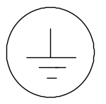 | Protective conductor terminal.
~ | Alternating current

Introduction and Applications

Introduction
The PT 5201 Compact VariTimeTM Sync Generator includes all basic features for professional sync, timing and test signals in one half-sized box.

The new digital studios need cost efficient and reliable synchronization for the main equipment to work reliably. For this purpose PTV offers the PT 5201 as the fully integrated solution eliminating any costs associated with modular structures, support of many different signal types and extensive operating facilities.

Analog Black Burst is still routinely used for timing purposes, also in digital installations, where processing delays are often on the order of several fields.
The PT 5201 Compact VariTimeTM Sync Generator is designed with the multiple delays of digital television installations in mind, but also fulfils all synchronization requirements when used with a combination of digital and traditional analog video systems.
The PT 5201 Compact VariTimeTM Sync Generator is a multi-standard sync generator and provides sync and test signals for both NTSC, PAL and for SDI outputs of 525/59.94 and 625/50 systems.
Each of the reference Black Burst outputs and the Test Signal Generator output can be individually selected in system (NTSC/PAL) and timed in fine steps over the complete sequence.
The serial digital black and test signals can be timed with a resolution of 37 ns over a ±1 field range.
The analog Black bursts are timeable in sub-nanosecond resolution over a ±4 fields sequence for PAL and ±2 fields sequence for NTSC.
The timing of analog Test Signal Generator follows the timing of the SDI generator, i.e. with a 37ns resolution but over a ±4 fields sequence for PAL and ±2 fields sequence for NTSC.

Configuration
The operation of PT 5201 Compact VariTimeTM Sync Generator is based on a Windows interface. The Windows interface makes it easy to manage all timing, patterns and audio features in one screen.
The settings for the Windows interface are either loaded from the PC or downloaded from the generator. When the settings are loaded from the PC the data is transferred immediately to the generator, overwriting the actual state.
At exit from the panel, data is stored in a file on the PC for later use.
Four presets can be stored in the instrument and also in 4 separate files on the PC. Any preset can then be recalled either from the PC or from the generators internal memory.
The hidden button on the front plate can select the stored presets in the generator.
Communication between PT 5201 and PC via standard RS-232 protocol makes it possible to use any kind of PC.
Status of current functions and systems will be displayed at any time corresponding to the LED’s on the PT 5201 front panel.

Applications
The PT 5201 is designed to manage slave as well as master operations as a stand-alone unit.
In systems where PT 5201 operates as a master the reference is locked to an internal, high stability TCXO oscillator (Temperature Controlled Xtal Oscillator)

For use in slave applications the genlock function is used.
The genlock function features genlock to NTSC and PAL video signals, Black Burst house sync or a 10 MHz reference clock, e.g. from a GPS receiver. The genlock function features passive loop-through, and has a common timing facility for the generator.

Product Data

Safety Characteristics
This apparatus has been designed and tested in accordance with the safety Class I requirements of the IEC publication 1010-1 (“Safety Requirements for Electrical Measuring Apparatus”), and is safe as supplied. This manual contains information and warnings, which must be followed during operation to ensure operator and service personnel safety.

Performance Characteristics
Characteristics expressed in numerical values with stated tolerances are guaranteed tolerances, when the instrument is calibrated at 25°C and after 20-min. warm-up. Specified numerical data without tolerances indicate typical values at nominal ambient temperature (25°C) and reflects an average performance.

Summarized Data
The instrument has been developed based on the latest, relevant ITU, SMPTE, EBU, and AES/EBU specifications.

Master Frequency Reference TCXO

Temperature drift: ±2.5 ppm (0-50ºC, ref. 25ºC)

Ageing: ±1 ppm/year; first year then better

Remote Control

Input Interface: RS-232 port, 9 pole D-sub, male

Protocol: SCPI based

Baud rate. 9600 kbit

Analog Genlock

Input: 75 Ω looped through

Return loss: >36 dB to 6 MHz

Genlock Signal(M-NTSC or G-PAL)

Amplitude: Nominally ± 3 dB

S/N ratio: >26 dB

Input Sc-H phase: Nominally ±45º

Pull-in range fsc: ± 50 Hz

Jitter when locked to burst: < 0.5º

Jitter when locked to sync: < 2 ns

Timing facilities

Timing range: PAL: ±4 fields
NTSC: ±2 fields

Timing resolution: 0.5º at f_{SC}

Timing resolution

Analog Black Burst: 0.15 ns

TSG: 37 ns

Genlock Signal (Continuous frequency)

Continuous frequency reference: 10 MHz

Amplitude: 1 V ±3 dB

Analog Black Burst Outputs

Connector: BNC

Output impedance: 75 Ω ±0.5 Ω

Return loss: >36 dB, to 5 MHz

Sync amplitude: PAL: -300mV ±2%
NTSC: -286mV ±2%

Burst amplitude: PAL: 300mV ±2%
NTSC: 286mV ±2%

Timing range: PAL: ±4 fields
NTSC: ±2 fields

Timing resolution: 0.5º at fsc

Sc-H phase: Default 0^{o,} adjustment ± 180º, resolution <1^{o°}

S/N ratio: 60 dB unweighted to 5 MHz

Jitter: Burst jitter: ±0.5º
Sync jitter: ±0.5 ns (based on design and burst jitter value)

Test Signal Generator

SDI TSG output

Connector: BNC

Output impedance: 75 Ω ±0.5 Ω

Format: 270 Mb/s serial, complies with ITU-R BT 656 and SMPTE 259 M

Return loss: >15 dB, 5 – 270 MHz

Timing range: PAL: ±1 field
NTSC: ±1 field

Timing resolution: 37 ns
Jitter: ± 0.25 ns
Rise and fall time: 0.75 – 1.50 ns
Embedded Audio: 1kHz stereo, silence and Off

Analog TSG output
This output is primarily for testing purposes as its color phasing is unlocked to the Black Burst outputs.

Connector: BNC

Output impedance: 75 Ω ±0.5 Ω

Return loss: >36 dB, to 5 MHz

Sync amplitude: PAL: -300 mV ±2%
NTSC: -286 mV ±2%

Burst amplitude: PAL: 300 mV ±2%
NTSC: 286 mV ±2%

Video accuracy: Nominal ±2 %

Timing range: PAL: ±1 fields
NTSC: ±1 fields

Timing resolution: 37 ns,

Sc-H phase: Default 0º, adjustment ± 180º, resolution: 1.4º

S/N ratio: 50 dB unweighted to 5 MHz

Jitter: Burst jitter: ±0.5º at f_{sch}
Sync jitter: 0.5 ns (based on design and burst jitter value)

Common test signals, SDI and analog generator
All signals in standard 4x3 aspect ratio.

Patterns dedicated for PAL: EBU Color Bar
75% Color Bar + grey
75% Color Bar + red
CCIR Line 18

Patterns dedicated for NTSC: SMPTE Color Bar
FCC Color Bar

Patterns common for NTSC/PAL: Color Bar ITU801
Color Bar 100%
Crosshatch
PLUGE
SDI Check Field
Digital Grey
Staircase 5 step
Staircase 10 step
15 KHz Bl/Wh
White 100%
Black
Window 10%
Window 15%
Window 20%
Window 100%

AES/EBU Audio Generator
Serial digital audio generator with test tones.

Connector: XLR

Output format: Balanced 110 Ω ±20% According to AES3 1992
Amplitude: 3V_{PP} Typically
Data bitrate: 3.072 Mbit/s
Rise and Fall time: 5-30 ns
Jitter: < 20 ns
Coding: Linear, 20-bits two’s complement binary biphase mark
Pre-emphasis: None
Timing: +10.4 μs to -9.6 μs in 0.8 μs steps

AES/EBU Output signals
Tones: Stereo 500 Hz
Stereo 1 kHz
Stereo EBU 1 kHz, single click in ch. A
Stereo 8 kHz
Click rate: 1 or 3 s.

Levels: Silence
0 dBFS
-9 dBFS
-12dBFS
-15 dBFS
-16 dBFS
-18 dBFS
-21 dBFS

Wordclock (WCLK) Generator

Connector: BNC

Output impedance: 75 Ω ±0.5 Ω

Output characteristics: HC-MOS clock, 0 – 5 V un-terminated
Reference output: 44.1 or 48 kHz

The 48 kHz is both frequency and phase locked to the video.
The 44.1kHz is the CD audio sample frequency and frequency locked to the video frequency

Analog Audio Generator

Connector: XLR

Output format: Balanced 30 Ω ±10%
Balanced by active circuitry.
Amplitude: 0 dBm, 775 mV
Distortion: < 1 %

Analog audio output signals
Tones: Stereo 500 Hz
Stereo 1 kHz
Stereo EBU 1 kHz, single click in ch. A
Stereo 8 kHz
Click rate: 1 or 3 s.

Levels: +10 dBm
+8 dBm
+7 dBm
+6 dBm
+5 dBm
+4 dBm
+3 dBm
+2 dBm
+1 dBm
0 dBm
-1 dBm
-2 dBm
-3 dBm
-4 dBm
-5 dBm
-6 dBm
-7 dBm
-8 dBm
-9 dBm
-10 dBm
-11 dBm
-12 dBm
-13 dBm
-15 dBm
-18 dBm
-21 dBm
-24 dBm
-27 dBm
-30 dBm
-33 dBm
-36 dBm
Silence

Presets
Four preset set-ups can be stored in the unit. Besides essential data for the individual Presets all user accessible parameters for the outputs are included and stored in non-volatile memory.

The Presets are named Preset 1 – 4 in the unit.
In the Windows interface each preset is identified by:
Name (24 characters, no space)
Author
Date of modification
The preset name is displayed in the Preset Status box in the System Status window, when the preset is active, in the Windows Interface.
Preset status is also displayed by the front panel LEDs using the hidden Preset button. See operation instructions.

Environmental Conditions

Regulations and Standards
- EN 50081-1/1992 (emissions)
- EN 50082-1/1992 (immunity)

Climatic Conditions

Temperature range:
Storage: -30º - +70ºC (41ºF – 113ºF)
Ambient operating: +5º - +45ºC (-22ºF - +158ºF)

Humidity: Non condensing (IEC 721)

Mechanical Requirements

Vibration:

Limit range for storage and transport:
30 min. in each of three directions, 10 to 150 Hz; 0.7 mm_{p-p} and 50 m/s² max acceleration. According to IEC-Publ. 68, test Fc.
NOTE:
Unit mounted on vibration table without shock absorbing material.

Bump:

Limit range for storage and transport:
1000 bumps of 100 m/s² sine, 6 ms duration in each of 3 directions.
According to IEC-Publ. 68, test Eb.

Safety:

Comply to IEC1010-1

Power Supply

Voltage: 90 - 250 VAC

Frequency: 47 - 63 Hz

Power consumption: 22 W

Mechanical Data
Mechanical data for cabinet
Height: 42 mm (1.66")
Width: 217 mm (8.54")
Depth: 380 mm (15")
Weight: 1.5 kg (3.3 lbs)

Mechanical data for cabinet fitted with 19" rack mount
Height: 44 mm (1.73")
Width: 442 mm (18.4")
Depth: 380 mm (15")
Weight: 2.3 kg (5.1 lbs)

Mechanical data for two cabinets side by side, fitted with 19" rack mount
Height: 44 mm (1.73")
Width: 442 mm (18.4")
Depth: 380 mm (15")
Weight: 3.8 kg (8.4 lbs)

Page left intentionally blank

Installation

Accessories
Item: | Quantity: | Ordering Number:
Mains cable, EURO | As required | 4008 105 00020
Mains cable, US | As required | 4008 105 00030
Mains cable, UK | As required | 4008 105 01390
Interface cable | 1 | 4008 105 05220
Rack Mount kit | 1 | 4008 107 59590
CD-ROM | 1 | 4008 002 95110

Initial Inspection
Check the contents of the shipment for completeness and possible transport damage. If the contents are incomplete or damaged, a claim should be filed with the carrier immediately and the DK-Audio Sales or Service organization should be notified in order to facilitate the repair or replacement of the instrument.

Safety Instruction

Grounding
Before any other connection is made, the instrument must be connected to a protective earth conductor via the three-core mains cable.

At the rear there are means to extra safeguarding a proper grounding, e.g. for improved protection to lightning. A screw hole marked with


and a corresponding 4 mm screw with earth washer secures the connection.

Before connecting the equipment to the mains of the building installation, the proper functioning of the protective earth lead of the building installation needs to be verified.

Warning: Any interruption of the protective conductor inside or outside the instrumentis likely to make the instrument dangerous. Intentional interruption is prohibited.

Mains Voltage Cord and Fuses
Different power cords are available for the various voltage outlets.

Note:
If the mains plug has to be adapted to the local situation, a qualified person should only do it.
This instrument is equipped with a tap-less switch mode power supply that covers most nominal voltage ranges in use: 90-250V AC RMS. This obviates the need to adapt to the local mains voltage.
The mains frequency is 47-63 Hz.

Warning: This instrument is intended not to have the fuse renewed. If the fuse is damaged the power supply unit is also affected.

If the mains power supply has to be replaced please proceed as follows:
- Remove the mains cable
- Unscrew all 11 screws of the top cover
- Disconnect the power connector from the main PCB and the internal ground cable from the chassis
- Unbolt the power inlet from the rear panel and the PCB from the chassis stand-off’s
- Replace power supply unit and assemble in reverse order

The power supply is a safety and service part. The ordering number is 4008 109 86650

Rack Mounting

The PT 5201 Compact Varitime™ Sync Generator is in a half size 19” rack cabinet. The instrument is intended for rack mounting as well as desktop use. A rack mount kit for conventional 19” rack is included.

When the Sync Generator is used in desk top applications PTV recommend the mounting of the four self-adhesive rubber feet, included in the rack mount kit.

The included rack mount kit features ability to mount one or two units in a 19” rack system. The rack mount instruction, see below, specifies the parts.

Rack mount instructions
The PT 5201 is delivered with the following mounting parts:
1 pc. Side bracket
1 pc. Blind plate including rack mount ear
2 pc. Support base plates
4 pc Pan head screws M3x6 B
8 pc. Countersink screws M3x6 A
4 pc. Pan head screw M6x16 for rack frame
4 pc. Rack frame clips/nuts M6
4 pc. Rubber feet (for table top use)
Single PT 5201 with blind plate

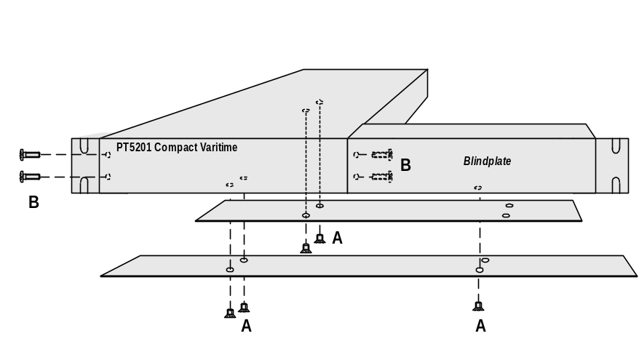
Single PT 5201 with Blind plate

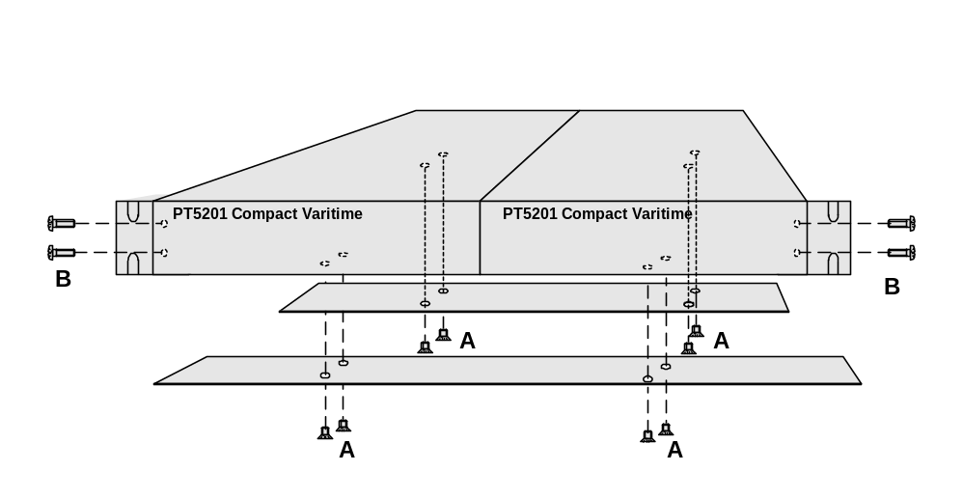
Double set of PT 5201

The PT 5201 has no built-in cooling fan and will therefore rely on air convection from the air vent holes in the front, back and sides of the cabinet. Do not cover the air vent holes.

If several cabinets are mounted above each other in a 19" rack, special attention must be paid to the temperature inside the rack.

If the PT 5201 is mounted between other instruments with high surface temperature, this cooling may not be sufficient. Under these circumstances, it is recommended to make space between the instruments, and to establish forced circulation (cooling) in the rack.

Access to and Replacement of Parts
Safety
The opening of covers or removal of parts, expect those to which access can be gained by hand, is liable to expose live parts.

The instrument must be disconnected from all voltage sources before performing any adjustment, replacement, maintenance, or repair, which requires the instrument to be opened. If repair of the opened instrument is unavoidable, it must be carried out only by a skilled person who is aware of the hazards involved. To guarantee safety only original spare parts must be used.

Access to the Units
To gain access to the units, remove the mains cable and unscrew the screws that secure the top cover of the instrument and lift the cover up.

Operating Instructions

Instrument description
The Sync Generator is designed with fixed hardware configuration (no options) for multiple broadcast standards.
All software configurations are controlled via remote in a Windows® interface and RS232 SCPI communication, see sec. 7, and the current generator output formats are indicated as matching LED’s on the front panel. The current and the Preset instrument settings are stored in the instrument Flash PROM memory. The instrument Preset settings are recalled from the Windows® interface or from the front panel Preset button, see sec. 6.2.

Front panel
The front panel LED’s of the Sync Generator indicates the operation status of each generator. The LED’s for the video outputs indicate the selected TV system (NTSC/PAL) for the given output.
The selected Audio Generator is indicated under AUDIO and the current clock frequency of the Wordclock output is given under WCLK.
The GENLOCK LED indicates the selected input reference is valid and the internal genlock loop is locked.
The POWER LED indicates the main power is on and the built in power supply, including the fuse, is intact.
Besides the D-SUB connector for communication to the PC a hidden button is placed on the front panel. This button is placed behind the front panel (for protection against unintended operation) and is accessible through a hole marked PRESET using a pen or equivalent tool. Pressing the PRESET button gives access to indication of selected preset, selecting another preloaded preset and resetting the entire unit to factory settings. For indicating the different preset modes the LED’s for the video generators (BB1-TSG for NTSC+PAL) is used as described in the scheme below.

PRESET indication:
 | According LED pair lit
No PRESET | No LED’s
PRESET 1 | BB1 (NTSC+PAL)
PRESET 2 | BB2 (NTSC+PAL)
PRESET 3 | BB3 (NTSC+PAL)
PRESET 4 | TSG (NTSC+PAL)

PRESET selection:
Impact to PRESET button | PRESET status | Indication on LED’s
A short press | Indicates active PRESET | One pair or no LED pair lit in 2 sec.
Hold for 3 sec. or more. | Scrolling through the PRESETs.  Stop when selected preset has been reached | LED pairs are scrolling
Hold for 20 sec. | FACTORY PRESET is loaded | After scrolling twice through all pairs, all LED’s are flashing twice
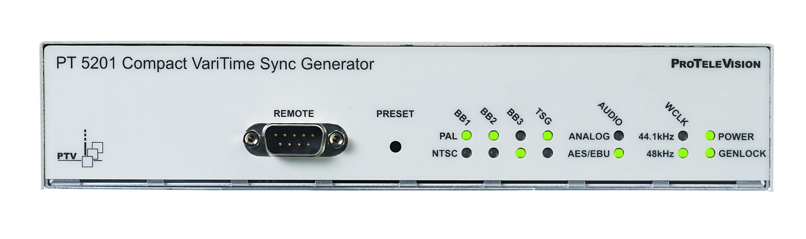
Front panel connector
The front panel connector is intended to interface the unit to PC control using a COM port. The connector is a D-SUB 9 pole male configured for RS232 communication based on SCPI protocol. See chap. 6.8 for technical description.

Connecting the interface cable from the PC to the unit special attention must be paid to the power source of both parties. When the controlling PC is mains power operated the ground potential of the mains power supply for both instruments has to be taking in consideration. To reduce problems concerning different mains power ground potential both instruments need to have common mains power source.

Negligence of this matter can cause damages to the PT 5201 or the PC COM port

How to get started
Instructions on how to connect your PT 5201 to the PC the very first time.

- Connect the PT 5201 Compact VariTime Sync Generator unit to the mains using the power cord.
- Using the interface cable connect PT 5201 to your PC by selecting COM1 (or COM2) on your PC and the D-SUB connector on the PT 5201 front panel.
- Place the CD-ROM in the drive of your PC. Copy PT 5201 Windows® interface to your hard drive and install the software by double click on the icon. The application software will search for previous settings in form of an INI file and will not find it. Click OK to no INI file found. The Windows® interface starts by an illustration of the front panel.
- You are now ready to start communication between the unit and the Windows® interface. In the Windows® interface toolbar click on Connect and Connect Using, which allows you to open the communication and synchronizes the settings.
Using Generator Settings will transfer the current settings of the unit to the Windows® interface.
PC Settings will transfer the initial settings of Windows® interface to the unit.
Viewing the entire configuration is done through clicking on View and System Status. To modify the settings for a specific generator double click inside the boundaries of the settings of each generator.

Rear panel
The rear panel of the unit contains all output connectors and also input connectors for genlock signals are placed here. Furthermore the rear panel features connectors for mains power and two ground terminals. All electrical specifications are specified under Product Data.
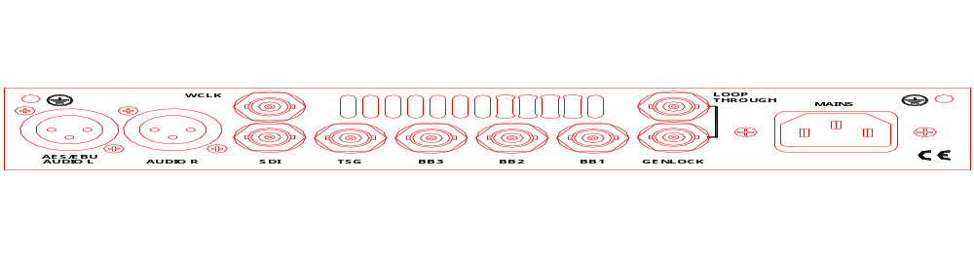

Windows interface

Application description
The Windows® interface is designed to serve as operating panel for PT 5201 Compact VariTime Sync Generator solely. It will not work with any other PTV product. All settings, configurations and calibration of Sync Generator are executed from the Windows® interface. The application can be run both online with the unit and offline using the software in DEMO MODE.
As mentioned in the introduction the Windows® interface will operate on any Windows® operating system from Windows® 95 and up, including Windows® NT. The interface application software is intended to run from the hard drive of a PC but the application can be executed from the CD-ROM itself, a network or other media. If the media is write protected or for other reasons the interface can’t install an INI file on the media, the last stored settings are read again.

Menu description
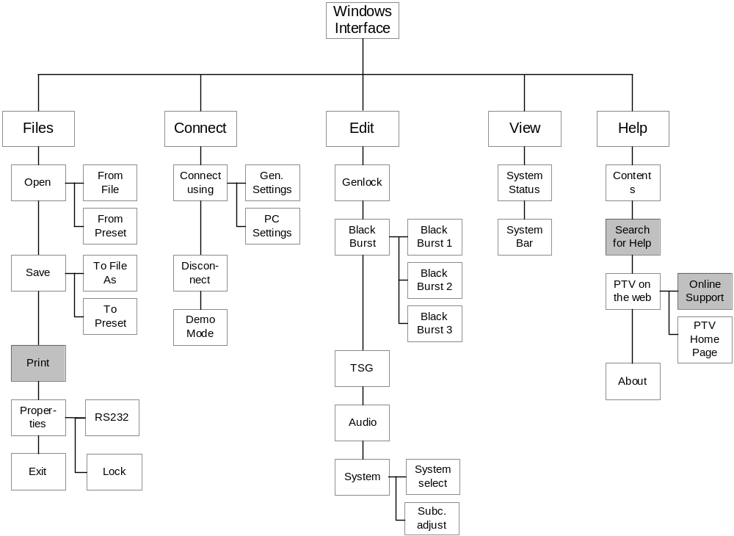
Fig. 1: Menu tree of PT 5201 Windows interface (grayed boxes are not implemented)

Files menu
The menus under Files are similar in nature to other Windows® applications. Here are menus featuring opening and saving presets and files. Furthermore the RS232 interface communication details and lock of calibration and editing are handled here.

Open
The Open menu enables you to open an already existing file or preset. Performing an Open commando will read the file or preset settings into the Windows® interface and give a connected unit the same set of configuration.
From File: Opening an already existing file will read the settings into the Windows® interface and give a connected unit the same set of configuration.
From Preset: Opening an already existing preset will read the settings into the Windows interface and give a connected unit the same set of configuration and leave the unit in the given preset status.

Save
The Save function enables you to save the current configuration into a file on the hard drive or as preset loaded in the memory of the connected unit.
To File: To Save To File will load the current configuration into a file on the hard drive. The file can be read by the Windows applications only and can be given any name.
To Preset: To Save To Preset enables you to load the current configuration into the memory of the connected unit. The preset can be given a name and a date and these data will be recognized by the Windows® interface. The unit can hold 4 different configurations in its preset bank and these can be selected from the front panel.

Print:
Not available

Properties
The Properties menu serve as control for the RS232 interface communication details and calibration and editing lock.
Connection the Connection menu enables you to modify the status of the RS232 interface communication port and indicate the default Baud rate and Flow Control. In the Port settings the communication port is selectable from COM1-COM4.
System: Checking the Lock Editing option will disable editing of the PT5201. Checking the Lock Calibration will disable user calibration.

Exit:
The Exit menu will close the Windows® interface and save the current settings in an INI file on the hard drive. If the media, from where the Windows® interface is executed, is write protected or you click on No to the question “Save changes to PT 5201 PC Remote Control?” no data is saved.

Connect menu
The features under the Connect menu serve as controls for the communication to the PT 5201unit.

Connect Using
The Connect Using menu opens the communication between the Windows® interface and a unit connected. The communication between the Windows® interface and the unit can be established in two modes depending on operation.
Generator Settings: The communication can be established by the Windows® interface reading the current settings of the unit. To open the communication click on the desired functionally.

PC Settings: The communication can be established by the Windows® interface writing its current/last settings. To open the communication click on the desired functionally.

Disconnect
Disconnect is used to abort communication between the Windows® interface and a connected unit before disconnecting the interface cable.

Demo Mode:
The Demo Mode is a way to demonstrate or operate the Windows® interface off line (no PT 5201 unit attached). Running the Windows® interface in Demo Mode give access to all the output features of the unit and access to store a set-up as a file. A set-up saved as a file can be uploaded to the unit at any time, when a unit is connected.

Edit menu
The menus under Edit all give direct access to the edit window to the given generator or access to the calibration routine.

Genlock
The Genlock facility enables you to lock all outputs of the PT 5201 to a number of relevant video and clock sources. The outputs of PT 5201 are locked to the source in frequency and phase.

System: System refers to the list of relevant video and clock sources PT 5201 is able to use as external reference.
PAL Burst and NTSC Burst mode PT 5201 will expect a video signal of the given system.
Internal mode: all outputs of PT 5201 are locked to the internal high stability TCXO oscillator.
10 MHz mode: the source is expected to be a 10 MHz reference. The internal oscillator will be locked to the reference and PT 5201 will act as in Internal Mode. Due to the internal reference the timing feature is disabled.
When the reference source is valid and the oscillator circuit is in lock, the ”Genlocked” LED on the front panel, will be lit.

Timing: All outputs of PT 5201 are timeable with reference to the Genlock video signal. All outputs are timed in parallel in resolution of the individual output. For timing details see Black Burst menu.

Black Burst
All three Black Burst outputs are digitally generated under the VariTimeTM system and are independent in timing and generation of TV system (NTSC/PAL).
The three Black Burst generators (BB1 – BB3) are identical in operation and functionality.

Black Burst Black Bursts are digitally generated under the VariTimeTM system and is independent in timing and generation of TV system (NTSC/PAL). The VariTimeTM system has a resolution of 0.15 ns and the timing range of 4 fields for NTSC and 8 fields for PAL.
System: The VariTimeTM outputs are able to generate Black Burst in the following formats:
PAL, PAL with ID and NTSC

Timing: The VariTime™ unit is generating Black Burst with a resolution of 0.15 ns and the timing range of 4 fields for NTSC and 8 fields for PAL.
Field, Line and Offset can be modified within their relevant limits.
Edit of the number of Fields, Lines or Offset of ns to be advanced or delayed can be done in 3 ways.
The modifications are typed directly in the edit boxes using number keys and sign.
Incrementing or decrementing by the up/down buttons, or using the timing bar.
Using the timing bar by grabbing the pointer with the mouse cursor and moving it, for quick timing.
ScH-Phase: The VariTimeTM system features adjustment of the ScH-Phase in the range of ±180º in a resolution of 1º, operated using the up/down buttons, or typed in directly.

TSG
The Test Signal Generator contains 23 basic patterns and signals, including Color Bars for the respective TV systems. The TSG outputs signals in two formats simultaneously, Analog Composite (TSG output) and SDI (SDI output) and has a common of 4 or 8 fields timing range in 37 ns resolution.
Analog and SDI Settings.
The SDI output features separate settings for embedded audio.
The Analog Composite output features ScH-Phase adjustment in 1º resolution.
Common settings:
System The TSG and SDI output generates patterns in both NTSC/525 lines and PAL/625 lines systems.
One common system for both output at a time.

Timing: The VariTime™ unit is generating Analog and Digital test signal outputs with a resolution of 37 ns and the timing range of 4 fields for NTSC and 8 fields for PAL.
Field, Line and Offset can be modified within their relevant limits.
Edit of the number of Fields, Lines or Offset of ns to be advanced or delayed can be done in 3 ways.
The modifications are typed directly in the edit boxes using number keys and sign.
Incrementing or decrementing by the up/down buttons, or using the timing bar.
Using the timing bar by grabbing the pointer with the mouse cursor and moving it, for quick timing.

ScH-Phase: The VariTimeTM system features adjustment of the ScH-Phase for the analog test signal generator in the range of ±180º in a resolution of 1º, operated using the up/down buttons, or typed in directly.

Pattern: The Test Signal Generator contains 21 basic patterns and signals, including Color Bars for the respective TV systems.
The list of signals consists of 19 patterns for NTSC and 21 patterns for PAL.
The TSG outputs signals in two formats simultaneously, Analog Composite (TSG output) and SDI (SDI output).
Analog Settings: The Analog Composite output features common timing and ScH-Phase adjustment in 1º resolution.

SDI Settings: The SDI output features common timing and separate settings for embedded audio.

Audio
PT 5201 contains two independent audio generators, Analog Audio and AES/EBU digital audio and a WordClock output (WCLK).
Due to common rear connectors, only one audio generator can be active at a time.
The AES/EBU generator features selectable sample rate, video reference lock, timing and a number of tones and levels.
The Analog Audio generator features four tones in a large number of levels and right channel identification.

Output Selectable between Analog audio and digital AES/EBU.
Some of the fields in the menu may be greyed out, indicating that this parameter is not valid for that format.

System In Genlocked mode the AES/EBU generator locks to both video systems and in Internal mode the audio generator is locked to the internal reference.
Timing Editing can be done in 3 ways.
The modifications are typed directly in the edit box using number keys.
Incrementing or decrementing by the up/down buttons, or using the timing bar.
Using the timing bar by grabbing the pointer with the mouse cursor and moving it, for quick timing.
Click Period Selected by ticking off the appropriate field
Wordclock Selectable between standard 48kHz and CD-audio sample frequency of 44.1kHz.
Tone Selectable in the field between a number of frequencies.
Level Selectable by using the scroll bar.

System
The System menu enables you to calibrate the main oscillator using this Windows® interface. Also all video outputs can be set to the same TV system (NTSC/PAL) during a Factory Reset.
Performing a Factory Reset replace all current settings with the settings the unit has from factory and will not affect any of the four user presets.

Factory Reset: Factory Reset overwrites all current settings with the settings the unit has from factory.
The reset is selectable between: NTSC,/525 or PAL/ 625

The factory settings:
- Internal reference
- No time advancing of Video outputs
- AES/EBU Audio at 48 kHz.

Note: Factory Reset will not affect the memory of any of the four user presets.

Calibration: The calibration menu enables you to calibrate the unit without taking it out of a rack and out of service. The unit is calibrated using this Windows® interface and a general-purpose counter connected to the BB1 terminal.
This adjustment will affect the frequency of the main oscillator only; no other circuits needs frequent calibration. To secure the factory calibration the unit is secured with a calibration lock function

Calibration procedure:
- Turn on the unit and connect it to a PC running the Windows® interface
- Connect a general-purpose counter (better than 0.1ppm in tolerance) to the Black Burst output.
- Unlock the calibration mode in Files/Properties/System and enter the calibration menu at Edit/System/Calibration
- Click on Unlock and expect a TTL clock at 4.5 MHz on the BB1 connector. There is now access to calibrate the main oscillator and using the up/down buttons to calibrate the BB1 outputs to 4,500,000 Hz.
- The calibration is stored in the unit by clicking on Save. By clicking on Cancel at any time before clicking on Save, the calibration mode will be terminated and the unit will hold the present calibration.

Note: Make sure to lock the calibration mode in Files/Properties/System to ensure no calibration is made by mistake.

View menu

System Status:
The System Status window will expand the Front Panel window and provide a view of settings of all outputs.
Besides information on timing, pattern and audio types and tones, the System Status gives information on unit serial no., SW release, Preset Status and serial communication (SCPI) status.
Editing of the settings is accessible by double click on each generator. By double click on a generator the corresponding generator window opens and enables editing.

The System Status window is not default and opens by checking System The settings are stored in an ini file on the used PC.

Status Bar:
The Status Bar is default and is shown below the Front Panel or System Status window. This bar provides information on communications from the Windows® interface to the connected unit.
The Status Bar states if an unit is present or not (connected/disconnected), which COM port is selected and baud rate. Also it shows if the Windows® interface is used in Demo Mode.

Remote Interface
Reference documents

IEEE 488.2-1987: IEEE Standard Codes, Formats, Protocols, and Common Commands
SCPI 1995.0: Standard Commands for Programmable Instruments, Vol I-IV.

General Description of the Interface Syntax

Connector Description

Connector type:
9 pin sub-D male
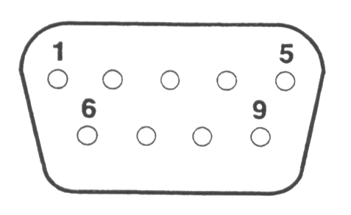

Protocol
The serial remote operates electrically as an RS 232C communication port. The parameter setting for the RS 232 communication port is described in paragraph 7.7.4, page 7-14.
PT 5201
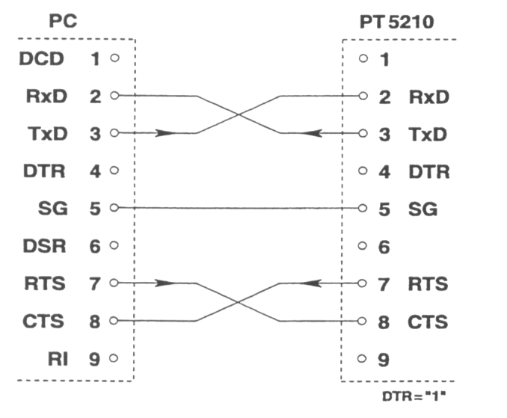

Minimum Configuration of cable between PC and PT5201.

NOTE: A standard “NULL-MODEM” cable may be used as well
The PT 5201 communication protocol complies with the:
- SCPI 1995.0:
Standard Commands for Programmable Instruments, Vol I-IV. This protocol which is based on the IEEE 488.2 (IEEE Standard Codes, Formats, Protocols, and Common Commands).

For the description of the commands a basic knowledge of operation of the instrument is assumed.

To use the serial remote interface a basic knowledge of the SCPI programming and computer control is also recommended. The paper: "A beginner's Guide to SCPI" by Barry Epler, Hewlett-Packard Press®, 1991 can be used to gain the basic knowledge of the ideas behind the SCPI system.

CONFIGURATION AND SYNTAX

Control characters of the RS232 interface:

 | Control character | Function
 | 0A_{hex} | Terminator, i.e. new line <LF>

Buffers:

Receive buffer: 512 bytes
Transmit buffer: 128 bytes.

Serial port:

The 9-pin RS232 connector consists of
Pin Name Description
1: DCD Not used
2: RxD Receiver pin
3: TxD Transmitter pin
4: DTR Not used
5: SG Signal ground
6: DSR Not used
7: RTS Request to send
8: CTS Clear to send
9: RI Not used.

General Information
The remote system is organized in a tree structure. The structure defines sub-systems. In order to access command lower in the tree or in different branches the entire command string should be used. Indentation is used to indicate the root level and the branches. The highest level to the left. The complete command always includes all the root levels.

A space between a command string and an option is required, except in a query * where a space is not allowed.

Enter more than one command on a line by using a semicolon “;” as divider. A command line is terminated by <CR> >LF>. If the next command is part of the same command system the separation is a “;” only. If the next command is part of another command system the “;” is followed by a “;”.

Parameters are separated from the header by a space. A comma separates several parameters.

Character strings should be placed in single or double quotation marks.

The valid parameter ranges are shown in the command tables. Non valid values generate an error message.

Syntax Elements
; | Semicolon separates two commands of a command line and does not change the path.
: | Colon separates the keywords of a command. In a command line, a colon “:” after a separating semicolon “;” indicates the root control level.
, | Comma separates the parameter command.
? | Question mark identifies a query command (Query commands are formed by adding a question mark to the header).
* | Asterisk identifies a common command. (Common commands consists of a header preceded by an asterisk and possibly followed by one or more parameters)
’ or ” | Single or double quote introduces and terminates a character string.
# | Double dagger introduces block data.
Space | Space Character separates header and parameters.
| | Parameters divided by a “|” indicates an “or” selection between the values shown. Only one value may be used at a time.
[xxxx] | Square brackets indicate an optional specific string parameter used by some command systems.
XXXX | A vertical line through a command indicates a command not implemented. The command is included for future compatibility reasons. The generator will not give any response to this command (error messages are not generated).

Command Syntax
A command consists of a “header” and one or several “parameters”. Header and parameters are separated by space.

A header may consist of several keywords.

Syntax of Program Messages
A command or query is called a program message unit. Such a program message unit consists of a header, or a header separated by a space from one or more parameters. The program header separator between the header and the first parameter must be at least one “white space” character. The header consists of one or more mnemonics (key words) describing the command. The parameters in a message unit are also referred to as “Data Elements”. They are mutually separated by a comma (,), which is referred to as “Data Separator”. Furthermore the following rules are valid:
- Any one of the “white space” characters (dec. 0..9, 11.. 32) may:
- precede a header
- precede the Message Terminator
- be placed in between the header and the parameter
- be placed in between two consecutive parameters
- String data in a parameter must be specified between quotes. A quote may either be a “single quote” (dec. 39) or a “double quote” character (dec. 34)

One or more program message units (commands) may be send within a single program message. Program message units are separated by a semicolon (;). A message of one or more units is terminated by a program message terminator.

The program message terminator must be the following code:
- LF <line feed> (dec.10) code

Note:
Most controller programming languages send the terminator automatically, but allow it to be changed.

Basically there are two types of program headers:
- Compound headers
Commands have a compound header consisting of one of more key words (mnemonics), mutually separated by a colon (:) character. Such as a colon may also precede the header.
- Command headers
The program messages that are standardized are called common commands. Their headers always start with an asterisk (*) character

Each key word in a compound command header represents a node in the command tree. The left most key word is the root node, representing the highest hierarchical level in the command tree. Subsequent keyword represents sub nodes under the root node.

Long and Short Form
Program messages may be sent in either long or short form
- The long form is the full word
- The short form is the first character of the long form

The short form in a syntax specification is shown in upper case, and the remaining part of the long form is shown in lower case characters.

Note:
Upper and lower case, as used in syntax specification, is only a notation habit to facilitate distinction between long and short form. The generator itself does not differentiate between upper and lower case characters.
In program messages, either the long or short form may be used in any mix of upper or lower case characters. There is no semantic difference between upper and lower case in program messages.

Syntax of Response Messages
The response to a query is a response message unit, consisting of one or more parameters (data elements). Successive parameters are separated by a comma (,). If there are multiple queries in a program message, the multiple response message units are grouped together in the corresponding response message.

Response message units are separated by a semicolon (;) and are terminated by a response message terminator.

The instrument will always send the response data in capitals. Headers are not sent in the response messages, parameters only.

intentionally blank

Commands summary
All commands listed consists of both a set- and request-command unless specifically listed in the table as <query only> or <no query>

Mandated Commands
Command | Parameter | Status after *RST | Remarks
*CLS | - |  | Clear Status Command
*ESE
*ESE?
*ESR?
*IDN? |  |  | Device identification query
*OPC
*OPC?
*RST |  |  | Reset Command
*SAV | <1 to 4 >
*RCL | <1 to 4 >
*SRE
*SRE?
*STB?
*TST?
*WAI

Required commands

SYSTem subsystem
Command | Parameter | Status after *RST | Remarks
:ERRor? |  | - | <query only>
:VERSion? |  | - | <query only>
:PRESet
[:RECall] | <1 to 4>
:STORe | <1 to 4>
:NAME | <1 to 4>,<name> |  | Note 1
:AUTHor | <1 to 4>,<author name> |  | Npte 1
:DATE | <1 to 4> [,<year>,<month>,<day>]

STATus subsystem
Command | Parameter | Status after *RST | Remarks
:OPERation
[:EVENt]? |  |  | <query only>
:CONDition?
:ENABle
:ENABle?
:QUEStionable
[:EVENt]? |  |  | <query only>
:CONDition
:ENABle
:ENABle?
:PRESet

Instrument commands

INPut subsystem
Command | Parameter | Status after *RST | Remarks
:GENLock
:SYSTem | INTernal|PALBurst|  NTSCburst|F10MHZ | INTernal
:DELay | <Field>,<Line>,<HTime> | 0,0,0
:CALibrate
:ENABLe :ENABle | OFF|ON
:ADJust | UP|DOWN|MIN|MAX
:STORe :STORe | - |  | <no query>
:GENLock? | - | - | <query only>

OUTPut subsystem
Command | Parameter | Status after *RST | Remarks
:BB1
:SYSTem | PAL|PAL_ID|NTSC | PAL
:DELay | <Field>,<Line>,<Htime> | 0,0,0
:SCHPhase | <-179 to 180> | 0
:BB1? | - | - | <query only>
:BB2
:SYSTem | PAL|PAL_ID|NTSC | PAL
:DELay | <Field>,<Line>,<Htime> | 0,0,0
:SCHPhase | <-179 to 180> | 0
:BB2? | - | - | <query only>
:BB3
:SYSTem | PAL|PAL_ID|NTSC | PAL
:DELay | <Field>,<Line>,<Htime> | 0,0,0
:SCHPhase | <-179 to 180> | 0
:BB3? | - | - | <query only>
:TSGenerator
:PATTern | See Chap. 10, PT5201 Signals | CBEBu
:SYSTem | PAL|NTSC | PAL
:DELay | <Field>,<Line>,<Htime> | 0,0,0
:SCHPhase | <-179 to 180> | 0 | 1,4° resolution
:EMBaudio | See Chap. 10, PT5201 Signals |  | Digital output only
:TSGenerator? | - | -
[:SIGNal]
:AUDio |  |  | <no query>
[:OUTPut] | ANALog|AESebu | AESebu
:ANALog
:SIGNal | See Chap. 10, PT5201 Signals
:LEVel | See Chap. 10, PT5201 Signals | SILence
:CLICk | 1|3
:ANALog?
:AESebu
:SYSTem | PAL|NTSC
:SIGNal | See Chap. 10, PT5201 Signals
:LEVel | See Chap. 10, PT5201 Signals | SILence
:TIMing | See Chap. 10, PT5201 Signals | PAL | Only 48kHz
:WORDclock | F441KHZ | F48KHZ
:CLICk | 1|3
:AESebu?

Note 1:String data may NOT contain any spaces as this is not supported in this version.

Page left intentionally blank

Commands Explanation.

Mandated Commands

- *CLS CLEAR STATUS
Clear the SCPI error queue.

- *ESE STANDARD EVENT STATUS ENABLE COMMAND
The device accepts this command but the functionality has not been implemented in this version.

- *ESE? STANDARD EVENT STATUS ENABLE QUERY
The device responds to this command but the functionality has not been implemented in this version, i.e. the answer should be ignored.

- *ESR? STANDARD EVENT STATUS REGISTER QUERY
The device responds to this command but the functionality has not been implemented in this version, i.e. the answer should be ignored.

- *IDN? IDENTIFICATION QUERY
The response contains four fields:
Field 1: Company name
Field 2: Product name
Field 3: KU number
Field 4: Software release, i.e. the software status of all programmable parts in the PT5201.

Example:*IDN? response: PTV,PT5201,KU012345,1.0

- *OPC OPERATION COMPLETE
The device accepts this command but the functionality has not been implemented in this version.

- *OPC? OPERATION COMPLETE QUERY
The device accepts this command but does not respond to it because the functionality has not been implemented in this version.

- *RST RESET
Resets the device to factory preset status. The four presets are NOT reset, i.e. any user preset will NOT be erased

- *SAV SAVE PRESET
Please refer to the command: SYSTem:PRESet:STORe

- *RCL RECALL PRESET
Please refer to the command: SYSTem:PRESet:RECall

- *SRE SERVICE REQUEST ENABLE
The device accepts this command but the functionality has not been implemented in this version.

- *SRE? SERVICE REQUEST ENABLE QUERY
The device responds to this command but the functionality has not been implemented in this version, i.e. the answer should be ignored.

- *STB? READ STATUS BYTE QUERY
The device responds to this command but the functionality has not been implemented in this version, i.e. the answer should be ignored.

- *TST? SELF-TEST QUERY
The device accepts this command but the functionality has not been implemented in this version.

- *WAI WAIT TO CONTINUE
The device accepts this command but does not respond to it because the functionality has not been implemented in this version.

Required Commands

SYSTem commands

- SYSTem:ERRor?
Command for reading an SCPI error message from the error queue. See chapter: 9. Error Codes for a complete list of error codes.

Example:
SYST:ERR? response: -102,”Syntax error”

SYSTem:VERSion?
Command for reading the SCPI version to which the RS232 implementation complies.

Example:
SYST:VERS? response: 1995.0

- SYSTem:PRESet[:RECall]
Command to recall a stored generator configuration from a preset. Four user presets from 1 to 4 are available.

Example:
SYST:PRES:REC 3 recall preset 3.
SYST:PRES:REC? response: 3, i.e. preset 3 is currently active

- SYSTem:PRESet:STORe
Command to store the actual configuration in a preset. Four user presets from 1 to 4 are available.

Example:
SYST:PRES:STOR 2 store configuration in preset 2

- SYSTem:PRESet:NAME
Command for naming a user preset. Four user presets from 1 to 4 are available. The number of characters in the name are limited to sixteen, 16, and may NOT contain spaces.
Example:
SYST:PRES:NAME 2,”WHAT” name preset number 2 “WHAT”
SYST:PRES:NAME? 2 response: “WHAT”

- SYSTem:PRESet:AUTHor
Command for naming the author of a user preset. Four user presets from 1 to 4 are available. Number of characters in the name are limited to sixteen, 16, and may NOT contain spaces.
Example:
SYST:PRES:AUTH 1,”Monroe” name author of preset number 2 to "Monroe"
SYST:PRES:NAME? 2 response: “MONROE”

- SYSTem:PRESet:DATE
Command for settings the date of a user preset. Four user presets from 1 to 4 are available. The date should be entered as year, month, day.
Example:
SYST:PRES:DATE 4,00,6,1 date preset number 2 to june1, 2000
SYST:PRES:DATE? 2 response: 00,6,1

STATus commands
- STATus:OPERation[:EVENt]?
- STATus:OPERation:CONDition?
- STATus:OPERation:ENABle
- STATus:QUEStionable[:EVENt]?
- STATus: QUEStionable:CONDition?
- STATus: QUEStionable:ENABle
The device accepts and responds to these commands, but the functionality has not been implemented in this version, i.e. any answer should be ignored.

- STATus:PRESet?
The device returns the status of the user preset, i.e. whether a user preset is active or not.

Examples:
STAT:PRES? response: 2, i.e. preset 2 is active
STAT:PRES? response: OFF, i.e. no preset is active

Instrument Commands

INPut commands
- INPut:GENLock:SYSTem

Command for selecting the genlock system. Possible selections are
System | Description
INTernal | Internal
PALBurst | PAL burst lock
NTSCburst | NSTC burst lock
F10MHZ | 10 MHz lock

Example:
INP:GENL:SYST F10MHZ set system to 10MHz lock
INP:GENL:SYST? response: F10MHZ

- INPut:GENLock:DELay
Command to set the delay for the genlock input. The delay is defined by three parameters
<Field>, <Line>,<HTime>
where <Field> sets the field offset, <Line> sets the line offset and <HTime> sets the horizontal time in ns, i.e.
HTime(PAL) < 64000.0ns
HTime(NTSC) < 63492.1ns
If this command is issued when the genlock system is internal or 10MHz the timing will be saved and restored whenever PALBurst of NTSCBurst is selected.
It is not possible to select a delay outside the range of the selected system. See the table below.
ANALOG
PAL, 625 lines |  | NTSC, 525 lines
Field | Line | Field | Line
-3 | -0, .., -312 | - | -
-2 | -0, .., -311 | - | -
-1 | -0, .., -312 | -1 | -0, .., -262
-0 | -0, .., -311 | -0 | -0, .., -261
+0 | +0, .., +312 | +0 | +0, .., +262
+1 | +0, .., +311 | +1 | +0, .., +261
+2 | +0, .., +312 | +2 | +0
+3 | +0, .., +311 | - | -
+4 | +0 | - | -

Example:
INP:GENL:DEL +2,+5,+123.5 set delay to 2 field, 5 line & 123.5ns
INP:GENL:DEL? response: +2,+005,+00123.5

- INPut:GENLock:CALibrate:ENABle
Command to enable calibration of the internal 10 MHz oscillator reference. This command must be issued before using the INP:GENL:CAL:ADJ command

Example:
INP:GENL:CAL:ENAB ON enable calibration of the internal 10 MHz reference
INP:GENL:CAL:ENAB? response: ON

- INPut:GENLock:CALibrate:ADJust
Command to calibrate the internal 10 MHz reference. The reference is adjusted by setting a parameter, which may be UP, DOWN, MIN or MAX. It is NOT possible to access and/or issue the actual values.

Example:
INP:GENL:CAL:ADJ UP increment the 10 MHz reference
INP:GENL:CAL:ADJ DOWN decrement the 10 MHz reference
INP:GENL:CAL:ADJ MAX set the reference to maximum deviation
INP:GENL:CAL:ADJ MIN set the reference to minimum deviation

- INPut:GENLock:CALibrate:STORe
Command to store the current setting of the internal 10 MHz reference.

- INPut:GENLock?
Command to display the status and the settings of the genlock. The response is defined as
<lock info>,<system>,<Field>,<Line>,<HTime>
where <lock info> is either GENLOCKED or UNLOCKED.
For an explanation regarding the rest of the response see the commands: INP:GENL:SYST and INP:GENL:DEL.
When selecting Internal or 10MHz system, the parameters <Field>,<Line>,<HTime> will have no meaning. In these cases the returned values should be discarded and only the relevant parameters should be used.

Important!
<lockinfo> is implemented in PT5201 unit SW ver. > 2.2 and later and PC Remote SW ver. > 1.3.

Examples:
INP:GENL? response: UNLOCKED,NTSCBURST,+1,+212,+00000.2
INP:GENL? response: GENLOCKED,F10MHZ,+1,+0,+0
INP:GENL? response: GENLOCKED,PALBURST,+1,+1,+1234

OUTPut commands
- OUTPut:BB1:SYSTem
- OUTPut:BB2:SYSTem
- OUTPut:BB3:SYSTem
Command to select the system of the three Black Burst output. Systems available are

System | Description
PAL | PAL
PAL_ID | PAL with line 7 pulse
NTSC | NTSC with setup

Example:
OUTP:BB1:SYST PAL_ID set system for BB output 1 to PAL with line 7 pulse
OUTP:BB1:SYST? response: PAL_ID

- OUTPut:BB1:DELay
- OUTPut:BB2:DELay
- OUTPut:BB3:DELay

Command to set the delay of the three Black Burst output. The delay is defined by three parameters <Field>, <Line>,<HTime>
where <Field> sets the field offset, <Line> sets the line offset and <HTime> sets the horizontal time in ns, i.e.
HTime(PAL) < 64000.0ns
HTime(NTSC) < 63492.1ns
It is not possible to select a delay outside the range of the selected system. See the table below.
ANALOG
PAL, 625 lines |  | NTSC, 525 lines
Field | Line | Field | Line
-3 | -0, .., -312 | - | -
-2 | -0, .., -311 | - | -
-1 | -0, .., -312 | -1 | -0, .., -262
-0 | -0, .., -311 | -0 | -0, .., -261
+0 | +0, .., +312 | +0 | +0, .., +262
+1 | +0, .., +311 | +1 | +0, .., +261
+2 | +0, .., +312 | +2 | +0
+3 | +0, .., +311 | - | -
+4 | +0 | - | -

Example:
OUTP:BB2:DEL -2,-4,-3245.2 set delay for BB output 2 to -2 field, -4 line & -3245.2ns
OUTP:BB2:DEL? response: -2,-004,-03245.2

- OUTPut:BB1:SCHPhase
- OUTPut:BB2:SCHPhase
- OUTPut:BB3:SCHPhase
Command to set the ScH-Phase of the three Black Burst output. The ScH-Phase value must be in the range
180 < ScH-Phase <= +180

Example:
OUTP:BB2:SCHP -160 set the ScHPhase for BB output 2 to -160deg
OUTP:BB2:SCHP? response: -160

- OUTPut:BB1?
- OUTPut:BB2?
- OUTPut:BB3?
Command to display the complete settings of the three Black Burst output. The response contains five fields:
<System>,<Field>,<Line>,<HTime>,<ScHPhase>
For an explanation of the response, see the commands: OUTP:BBn:SYST, OUTP:BBn:DEL and OUTP:BBn:SCHP, where n: 1-3

Example:
OUTP:BB1? response: PAL,+2,+123,+12345.5,-160

- OUTPut:TSGenerator:PATTern
Command to select the pattern of the TSG output. Refer to chapter 10 PT5201 Signals for a description of the patterns available.
Not all the patterns are available in both systems. Trying to select a pattern, which is not available in the active system, will result in an error, namely: -200,”Execution error”.

Example:
OUTP:TSG:PATT WIN100 set the pattern for a 100% window
OUTP:TSG:PATT? response: WIN100

- OUTPut:TSGenerator:SYSTem
Command to select the system of the TSG output. Systems available are
System | Description
PAL | PAL
NTSC | NTSC with setup

If the current pattern is invalid in the selected system, the pattern will be reset to a valid pattern in the new system. See chapter 10, PT 5201 Signals, for the pattern reset list.
Example:
OUTP:TSG:SYST PAL set the system for PAL
OUTP:TSG:SYST? response: PAL

- OUTPut:TSGenerator:DELay
Command to set the delay of the TSG output.. The delay is defined by three parameters
<Field>, <Line>,<HTime>
where <Field> sets the field offset, <Line> sets the line offset and <HTime> sets the horizontal time in ns, i.e.
HTime(PAL) < 64000.0ns
HTime(NTSC) < 63492.1ns
It is not possible to select a delay outside the range of the selected system. See the table below.
ANALOG
PAL, 625 lines |  | NTSC, 525 lines
Field | Line | Field | Line
-3 | -0, .., -312 | - | -
-2 | -0, .., -311 | - | -
-1 | -0, .., -312 | -1 | -0, .., -262
-0 | -0, .., -311 | -0 | -0, .., -261
+0 | +0, .., +312 | +0 | +0, .., +262
+1 | +0, .., +311 | +1 | +0, .., +261
+2 | +0, .., +312 | +2 | +0
+3 | +0, .., +311 | - | -
+4 | +0 | - | -

Example:
OUTP:TSG:DEL -2,-4,-3245.2 set the delay for the TSG to -2 field, -4 line & 3245.2ns
OUTP:TSG:DEL? response: -2,-004,-03245.2

- OUTPut:TSGenerator:SCHPhase
Command to set the ScH-Phase of the TSG output. The ScH-Phase value must be in the range
180 < ScH-Phase <= +180

Example:
OUTP:TSG:SCHP -123 set the ScHPhase for -123deg
OUTP:TSG:SCHP? response: -123

- OUTPut:TSGenerator:EMBaudio:SIGNal
Command to select the signal of the embedded audio in the TSG SDI output. Refer to chapter 10 PT5201 Signals, for a description of the signals available.

Example:
OUTP:TSG:EMB:SIGN set the embedded audio to OFF
OUTP:TSG:EMB:SIGN? response: OFF

- OUTPut:TSGenerator?
Command to display the complete settings of the TSG output. The response contains seven fields:
<Pattern>,<System>,<Field>,<Line>,<HTime>,<ScHPhase>,<EmbAudio>
For an explanation of the response, see the commands: OUTP:TSG:PATT, OUTP:TSG:SYST, OUTP:TSG:DEL, OUTP:TSG:SCHP and OUTP:TSG:EMB:SIGN.

Example:
OUTP:TSG? response: CBEBU, PAL,+2,+123,+12345.5, -160,OFF

- OUTPut:AUDio:OUTput
Command to select the output of the audio signal. The output may be either analog or AES/EBU audio.

Example:
OUTP:AUD:OUTP AES select AES/EBU as the audio output
OUTP:AUD:OUTP? response: AESEBU

- OUTPut:AUDio:ANALog:SIGNal
Command to select the audio signal of the analog audio output signal. Refer to chapter 10, PT5201 Signals, for a description of the analog audio signals available.
Please note that the settings will be updated even though the output of the audio signal has been selected as AES/EBU. The settings will take effect the next time the analog audio output is selected.

Example:
OUTP:AUD:ANAL:SIGN S1KHZ set the analog audio signal to Stereo 1kHz
OUTP:AUD:ANAL:SIGN? response: S1KHZ

- OUTPut:AUDio:ANALog:LEVel
Command to select the audio level of the analog audio output signal. Refer to chapter 10, PT5201 Signals, for a description of the analog audio levels available.
Please note that the settings will be updated even though the output of the audio signal has been selected as AES/EBU. The settings will take effect the next time the analog audio output is selected.

Example:
OUTP:AUD:ANAL:LEV 4 set the analog audio level to +4dBm
OUTP:AUD:ANAL:LEV? response: 4

- OUTPut:AUDio:ANALog:CLICk
Command to select the click rate for the audio signal of the analog audio output signal. Refer to chapter 10, PT5201 Signals, for a description of the analog audio levels available. The click rate can be a click every 1 or 3 seconds.
Please note that the settings will be updated even though the output of the audio signal has been selected as AES/EBU. The settings will take effect the next time the analog audio output is selected.

Example:
OUTP:AUD:ANAL:CLIC 3 set the click rate to every 3 seconds
OUTP:AUD:ANAL:CLIC? response: 3

- OUTPut:AUDio:ANALog?
Command to display the complete settings of the analog audio output. The response contains three fields:
<Signal>,<Level>,<Click>
For an explanation of the response, see the commands: OUTP:AUD:ANAL:SIGN, OUTP:AUD:ANAL:LEV and OUTP:AUD:ANAL:CLIC.

Example:
OUTP:AUD:ANAL? response: S1KHZ,SILENCE,1

- OUTPut:AUDio:AESebu:SYSTem
Command to select the audio system of the AES/EBU audio output signal. Possible selections are PAL or NTSC
Please note that the settings will be updated even though the output of the audio signal has been selected as ANALOG. The settings will take effect the next time the AES/EBU audio output is selected.

Example:
OUTP:AUD:AES:SYST PAL set the AES/EBU audio system to PAL
OUTP:AUD:AES:SYST? response: PAL

- OUTPut:AUDio:AESebu:SIGNal
Command to select the audio signal of the AES/EBU audio output signal. Refer to chapter 10, PT5201 Signals, for a description of the AES/EBU audio signals available.
Please note that the settings will be updated even though the output of the audio signal has been selected as ANALOG. The settings will take effect the next time the AES/EBU audio output is selected.

Example:
OUTP:AUD:AES:SIGN S500HZ set the AES/EBU audio signal to Stereo 500Hz
OUTP:AUD:AES:SIGN? response: S500HZ

- OUTPut:AUDio:AESebu:LEVel
Command to select the audio level of the AES/EBU audio output signal. Refer to chapter 10, PT5201 Signals, for a description of the AES/EBU audio levels available.
Please note that the settings will be updated even though the output of the audio signal has been selected as ANALOG. The settings will take effect the next time the AES/EBU audio output is selected.

Example:
OUTP:AUD:AES:LEV -12 set the AES/EBU audio level to -12dBFS
OUTP:AUD:AES:LEV? response: -12

- OUTPut:AUDio:AESebu:TIMing
Command to select the audio timing of the AES/EBU audio output signal. Refer to chapter 10, PT5201 Signals, for a description of the AES/EBU audio timing available.
Please note that the settings will be updated even though the output of the audio signal has been selected as ANALOG. The settings will take effect the next time the AES/EBU audio output is selected.

Example:
OUTP:AUD:AES:TIM -1.6 set the AES/EBU audio timing to -1.6us
OUTP:AUD:AES:TIM? response: -1.6

- OUTPut:AUDio:AESebu:WORDclock
Command to select the sample rate of the AES/EBU generator and of the Wordclock output. The frequency can be either 44.1 or 48 kHz. Please note that the settings will be updated even though the output of the audio signal has been selected as ANALOG. The settings will take effect the next time the AES/EBU audio output is selected.

Example:
OUTP:AUD:AES:WORD F441KHZ set the sample rate to 44.1 kHz
OUTP:AUD:AES:WORD? response: F441KHZ

- OUTPut:AUDio:AESebu:CLICk
Command to select the click rate for the audio signal of the AES/EBU audio output signal. Refer to chapter 10 PT5201 Signals for a description of the analog audio levels available. The click rate can be a click every 1 or 3 seconds.
Please note that the settings will be updated even though the output of the audio signal has been selected as ANALOG. The settings will take effect the next time the AES/EBU audio output is selected.

Example:
OUTP:AUD:AES:CLIC 1 set the click rate to every 1 second
OUTP:AUD:AES:CLIC? response: 1

- OUTPut:AUDio:AES?
Command to display the complete settings of the AES/EBU audio output. The response contains six fields:
<System>,<Signal>,<Level>,<Timing>,<WordClock>,<Click>
For an explanation of the response, see the commands: OUTP:AUD:AES:SYST, OUTP:AUD:AES:SIGN, OUTP:AUD:AES:LEV, OUTP:AUD:AES:TIM, , OUTP:AUD:AES:WORD and OUTP:AUD:AES:CLIC.
Example:
OUTP:AUD1:AES? response: PAL,S500HZ,-12,-1.6,F441KHZ,1

Page left intentionally blank

Error Codes

Command errors [-199, -100]

Error Number | Error string  [description/explanation/example]
-100 | Command error  The command is invalid or incorrect.
-101 | Invalid character  A command or parameter contains an invalid character, e.g. a header containing an ampersand, SYST:VERS&.
-102 | Syntax error  An unrecognized command or data type was encountered, e.g. a string was received when the generator didn’t accept strings.
-103 | Invalid separator  A separator was expected, but an illegal character was encountered, e.g. the semicolon was omitted after a command, *IDN?:SYST:ERR?;
-104 | Data type error  A data element different from one allowed was encountered, e.g. numeric data was expected but string data was encountered.
-108 | Parameter not allowed  More parameters was received than expected for the command, e.g. the *IDN?; command accepts no parameters, so receiving *IDN? 2; is not allowed
-109 | Missing parameter  Fewer parameters was received than expected for the command, e.g. OUTP:BB1:DEL 2,2; is missing one parameter.
-110 | Command header error  An error was detected in the command header.
-111 | Header separator error  A character which is not a legal header separator was encountered, e.g. no white space followed the header, thus SYST:PRES:NAME”MACRO” is an error.
-112 | Program mnemonic too long  The header contains more than twelve characters.
-113 | Undefined header  The header is syntactically correct, but is not defined for the device.
-114 | Header suffix out of range  The command is invalid because the value of the numeric suffix attached to the program mnemonic is out of range, e.g. OUTP:BB12? is illegal because only 3 BB’s exists.
120 | Numeric data error  An error in the numeric data was encountered.
-121 | Invalid character in number  An invalid character for the data type was encountered, e.g. an alpha in a decimal value.
-123 | Exponent too large  The magnitude of the exponent was larger than 32000.
-124 | Too many digits  The mantissa of a decimal numeric data element contained more than 255 digits.
-128 | Numeric data not allowed  A legal numeric data was received, but the device does not accept one.
-130 | Suffix error  An error in the suffix was encountered.
-131 | Invalid suffix  The suffix is syntactically incorrect.
-134 | Suffix too long  The suffix contains more than twelve characters.
-138 | Suffix not allowed  A suffix was encountered after a numeric element, which does not allow suffixes.
-140 | Character data error  An error in the character was encountered.
-150 | String data error  An error in the string data was encountered.
-151 | Invalid string data  A string data element was expected, but was invalid for some reason, e.g. an END message was received before the terminal quote character.
-158 | String data not allowed  A string data element was received but was not allowed by the device.
-160 | Block data error  There is an error in the block data received.
-161 | Invalid block data  A block data was expected, but was invalid for some reason.
-170 | Expression error  There is an error in the expression received.

Execution errors [-299, -200]

Error Number | Error string  [description/explanation/example]
-200 | Execution error
-220 | Parameter error  Indicates that a program data element related error occurred.
-222 | Data out of range  Indicates that a legal program data element was received but could not be executed because the interpreted values was outside the range as defined by the device, e.g. the command OUTP:BB1:SCHP 200; is illegal since the ScHPhase can not exceed 180deg.
-223 | Too much data  Indicates that a legal program data element of block, expression, or string type was received that contained more data than the device could handle due to memory or related device-specific requirements.
-224 | Illegal parameter value  Used where exact value, from a list of possible’s, was expected.
-233 | Invalid version  Indicates that a legal program data element was parsed but could not be executed because the version of the data is incorrect to the device.

Device specific errors [-399, -300]

Error Number | Error string  [description/explanation/example]
-300 | Device-specific error
-350 | Queue overflow  A specific code entered into the queue in lieu of the code that caused the error. This code indicates that there is no room in the queue and an error occurred but was not recorded.
-360 | Communication error  A communication error on the serial port was detected
-361 | Parity error in program message  Parity bit not correct when data received on the serial port
-362 | Framing error in program message  A stop bit was not detected when data was received, e.g. a bad rate mismatch.
-363 | Input buffer overrun  Software or hardware input buffer on serial port overflows .

Query errors [-499, -400]

Error Number | Error string  [description/explanation/example]
-400 | Query error  An error occurred during a query.
-410 | Query INTERRUPTED  Indicates that a condition causing an INTERRUPTED Query error occurred.
-420 | Query UNTERMINATED  Indicates that a condition causing an UNTERMINATED Query error occurred.
-430 | Query DEADLOCKED  Indicates that a condition causing a DEADLOCKED Query error occurred.

PT 5201 Signals
Symbols:

X: Both G- and M-system.
G: Only in G-system.
M: Only in M-system

Video patterns.
 | Remote name | PT 5201
CBAR
SMPTE C.Bar | CBSMpte | M
EBU C.Bar | CBEBu | G
FCC C.Bar | CBFCc | M
C.Bar ITU801 | CBEBu8 | X
100% C.Bar | CB100 | X
75% C.Bar+Grey¹⁾ | CBGRey75 | G
75% C.Bar+Red²⁾ | CBRed75 | G
75% Red | RED75 | X
M.BURST
CCIR Line18 | CCIR18 | G
WINDOW
Window 10% | WIN10 | X
Window 15% | WIN15 | X
Window 20% | WIN20 | X
Window 100% | WIN100 | X
15kHz Bl/Wh | BLWH15KHZ | X
White 100% | WHITe100 | X
Black | BLACk | X
SPECIAL
SDI Check Field | SDICheck | X
Digital Grey | DGRey | X
LINEARITY
Staircase 5step | STAircase5 | X
Staircase 10step | STAircase10 | X
PATTERNS
Crosshatch | CROSshatch | X
PLUGE | PLUGe | X
¹⁾: 75% Colorbar + grey
²⁾: EBU (100%) colorbar +red

Pattern selections after system change
The tables apply when one or more signals only exists in one system.

COLORBAR GENERATOR:
PAL Specific patterns:
EBU C.Bar → SMPTE C.Bar
75% C.Bar+Grey → SMPTE C.Bar
75% C.Bar+Red → SMPTE C.Bar
CCIR Line18 → SMPTE C.Bar

NTSC specific patterns:
SMPTE C.Bar → EBU C.Bar
FCC C.Bar → EBU C.Bar

Audio signals

 | Remote name | Embedded | Analog | AES/EBU
Signals
Off | OFF | X
Silence | SILence | X
Stereo 500 Hz | S500HZ |  | X | X
Stereo 1 kHz | S1KHZ | X | X | X
Stereo EBU 1 kHz | SEBU1KHZ |  | X | X
Stereo 8 kHz | S8KHZ |  | X | X
Digital audio Levels
Silence | SILence |  | X | X
0 dBFS | 0 |  |  | X
-9 dBFS | -9 |  |  | X
-12 dBFS | -12 |  |  | X
-15 dBFS | -15 |  |  | X
-16 dBFS | -16 |  |  | X
-18 dBFS | -18 |  |  | X
-21 dBFS | -21 |  |  | X
Analog audio Levels
+10 dBm | 10 |  | X
+8 dBm | 8 |  | X
+7 dBm | 7 |  | X
+6 dBm | 6 |  | X
+5 dBm | 5 |  | X
+4 dBm | 4 |  | X
+3 dBm | 3 |  | X
+2 dBm | 2 |  | X
+1 dBm | 1 |  | X
0 dBm | 0 |  | X
-1 dBm | -1 |  | X
-2 dBm | -2 |  | X
-3 dBm | -3 |  | X
-4 dBm | -4 |  | X
-5 dBm | -5 |  | X
-6 dBm | -6 |  | X
-7 dBm | -7 |  | X
-8 dBm | -8 |  | X
-9 dBm | -9 |  | X
-10 dBm | -10 |  | X
-11 dBm | -11 |  | X
-12 dBm | -12 |  | X
-13 dBm | -13 |  | X
-15 dBm | -15 |  | X
-18 dBm | -18 |  | X
-21 dBm | -21 |  | X
-24 dBm | -24 |  | X
-27 dBm | -27 |  | X
-30 dBm | -30 |  | X
-33 dBm | -33 |  | X
-36 dBm | -36 |  | X
Silence | SILence |  | X
Digital AudioTiming
-9.6 μs | -9.6 |  |  | X
-8.8 μs | -8.8 |  |  | X
-8.0 μs | -8.0 |  |  | X
-7.2 μs | -7.2 |  |  | X
-6.4 μs | -6.4 |  |  | X
-5.6 μs | -5.6 |  |  | X
-4.8 μs | -4.8 |  |  | X
-4.0 μs | -4.0 |  |  | X
-3.2 μs | -3.2 |  |  | X
-2.4 μs | -2.4 |  |  | X
-1.6 μs | -1.6 |  |  | X
-0.8 μs | -0.8 |  |  | X
+0.0 μs | +0.0 |  |  | X
+0.8 μs | +0.8 |  |  | X
+1.6 μs | +1.6 |  |  | X
+2.4 μs | +2.4 |  |  | X
+3.2 μs | +3.2 |  |  | X
+4.0 μs | +4.0 |  |  | X
+4.8 μs | +4.8 |  |  | X
+5.6 μs | +5.6 |  |  | X
+6.4 μs | +6.4 |  |  | X
+7.2 μs | +7.2 |  |  | X
+8.0 μs | +8.0 |  |  | X
+8.8 μs | +8.8 |  |  | X
+9.6 μs | +9.6 |  |  | X
+10.4 μs | +10.4 |  |  | X

Reset configuration
Whenever the SCPI command *RST is issued and/or the preset button on the front is used as a reset, (pressing it for more than15seconds), the actual settings will be reset according to the following:

 | PAL | NTSC
BB1-3:
System | PAL | NTSC
Delay | 0,0,0.0 | 0,0,0.0
ScH-Phase | 0 | 0
TSG
Pattern | CBEBu | CBSMpte
System | PAL | NTSC
Delay | 0,0,0.0 | 0,0,0.0
ScH-Phase | 0 | 0
Embedded Audio | OFF | OFF
AES/EBU Audio | On | On
System | PAL | NTSC
Signal | S1KHZ | S1KHZ
Level | 0 | 0
Timing | 0 | 0
Click | 3 | 3
Wordclock | F48KHZ | F48KHZ
Signal | S1KHZ | S1KHZ
Analog Audio
Signal | S1KHZ | S1KHZ
Level | 0 | 0
Click | 3 | 3

Page left intentionally blank

END OF DOCUMENT

